**EBS & EFS Section Clean up:**

* We first need to delete the file system.

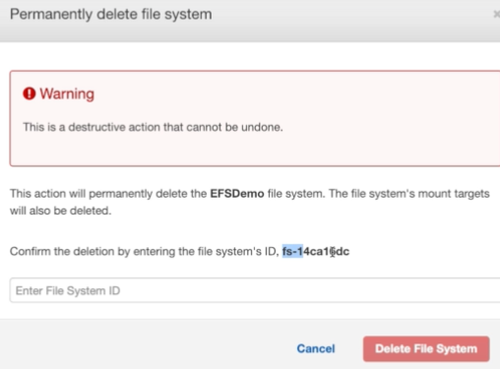

* Then terminate the EC2 instances.

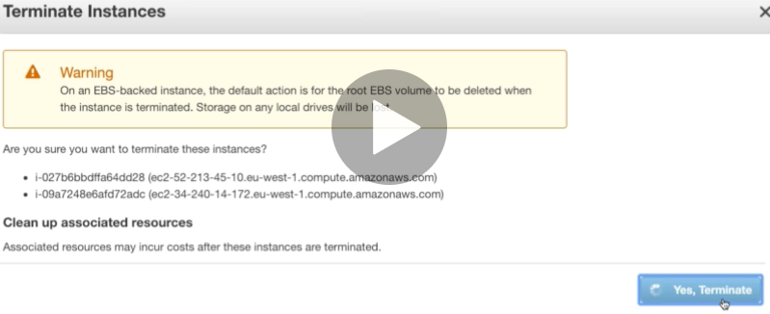

* Then delete the volumes.

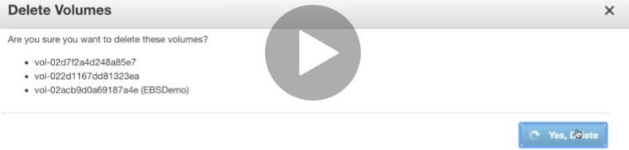

* After that, snapshots if we have any.

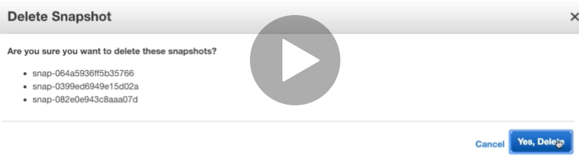

* Then finally security groups.

